Application Number | 07/2018/8717/FUL
Address | New Longton Sports & Social Club  Chapel Lane  New Longton
Applicant | Mr Stephen Yardley

Development | Installation of two-lane cricket nets.
Officer Recommendation | Approval with conditions

Date application valid | 21.11.2018
Target Determination Date | 25.01.2019
Extension of Time | 12.02.2019

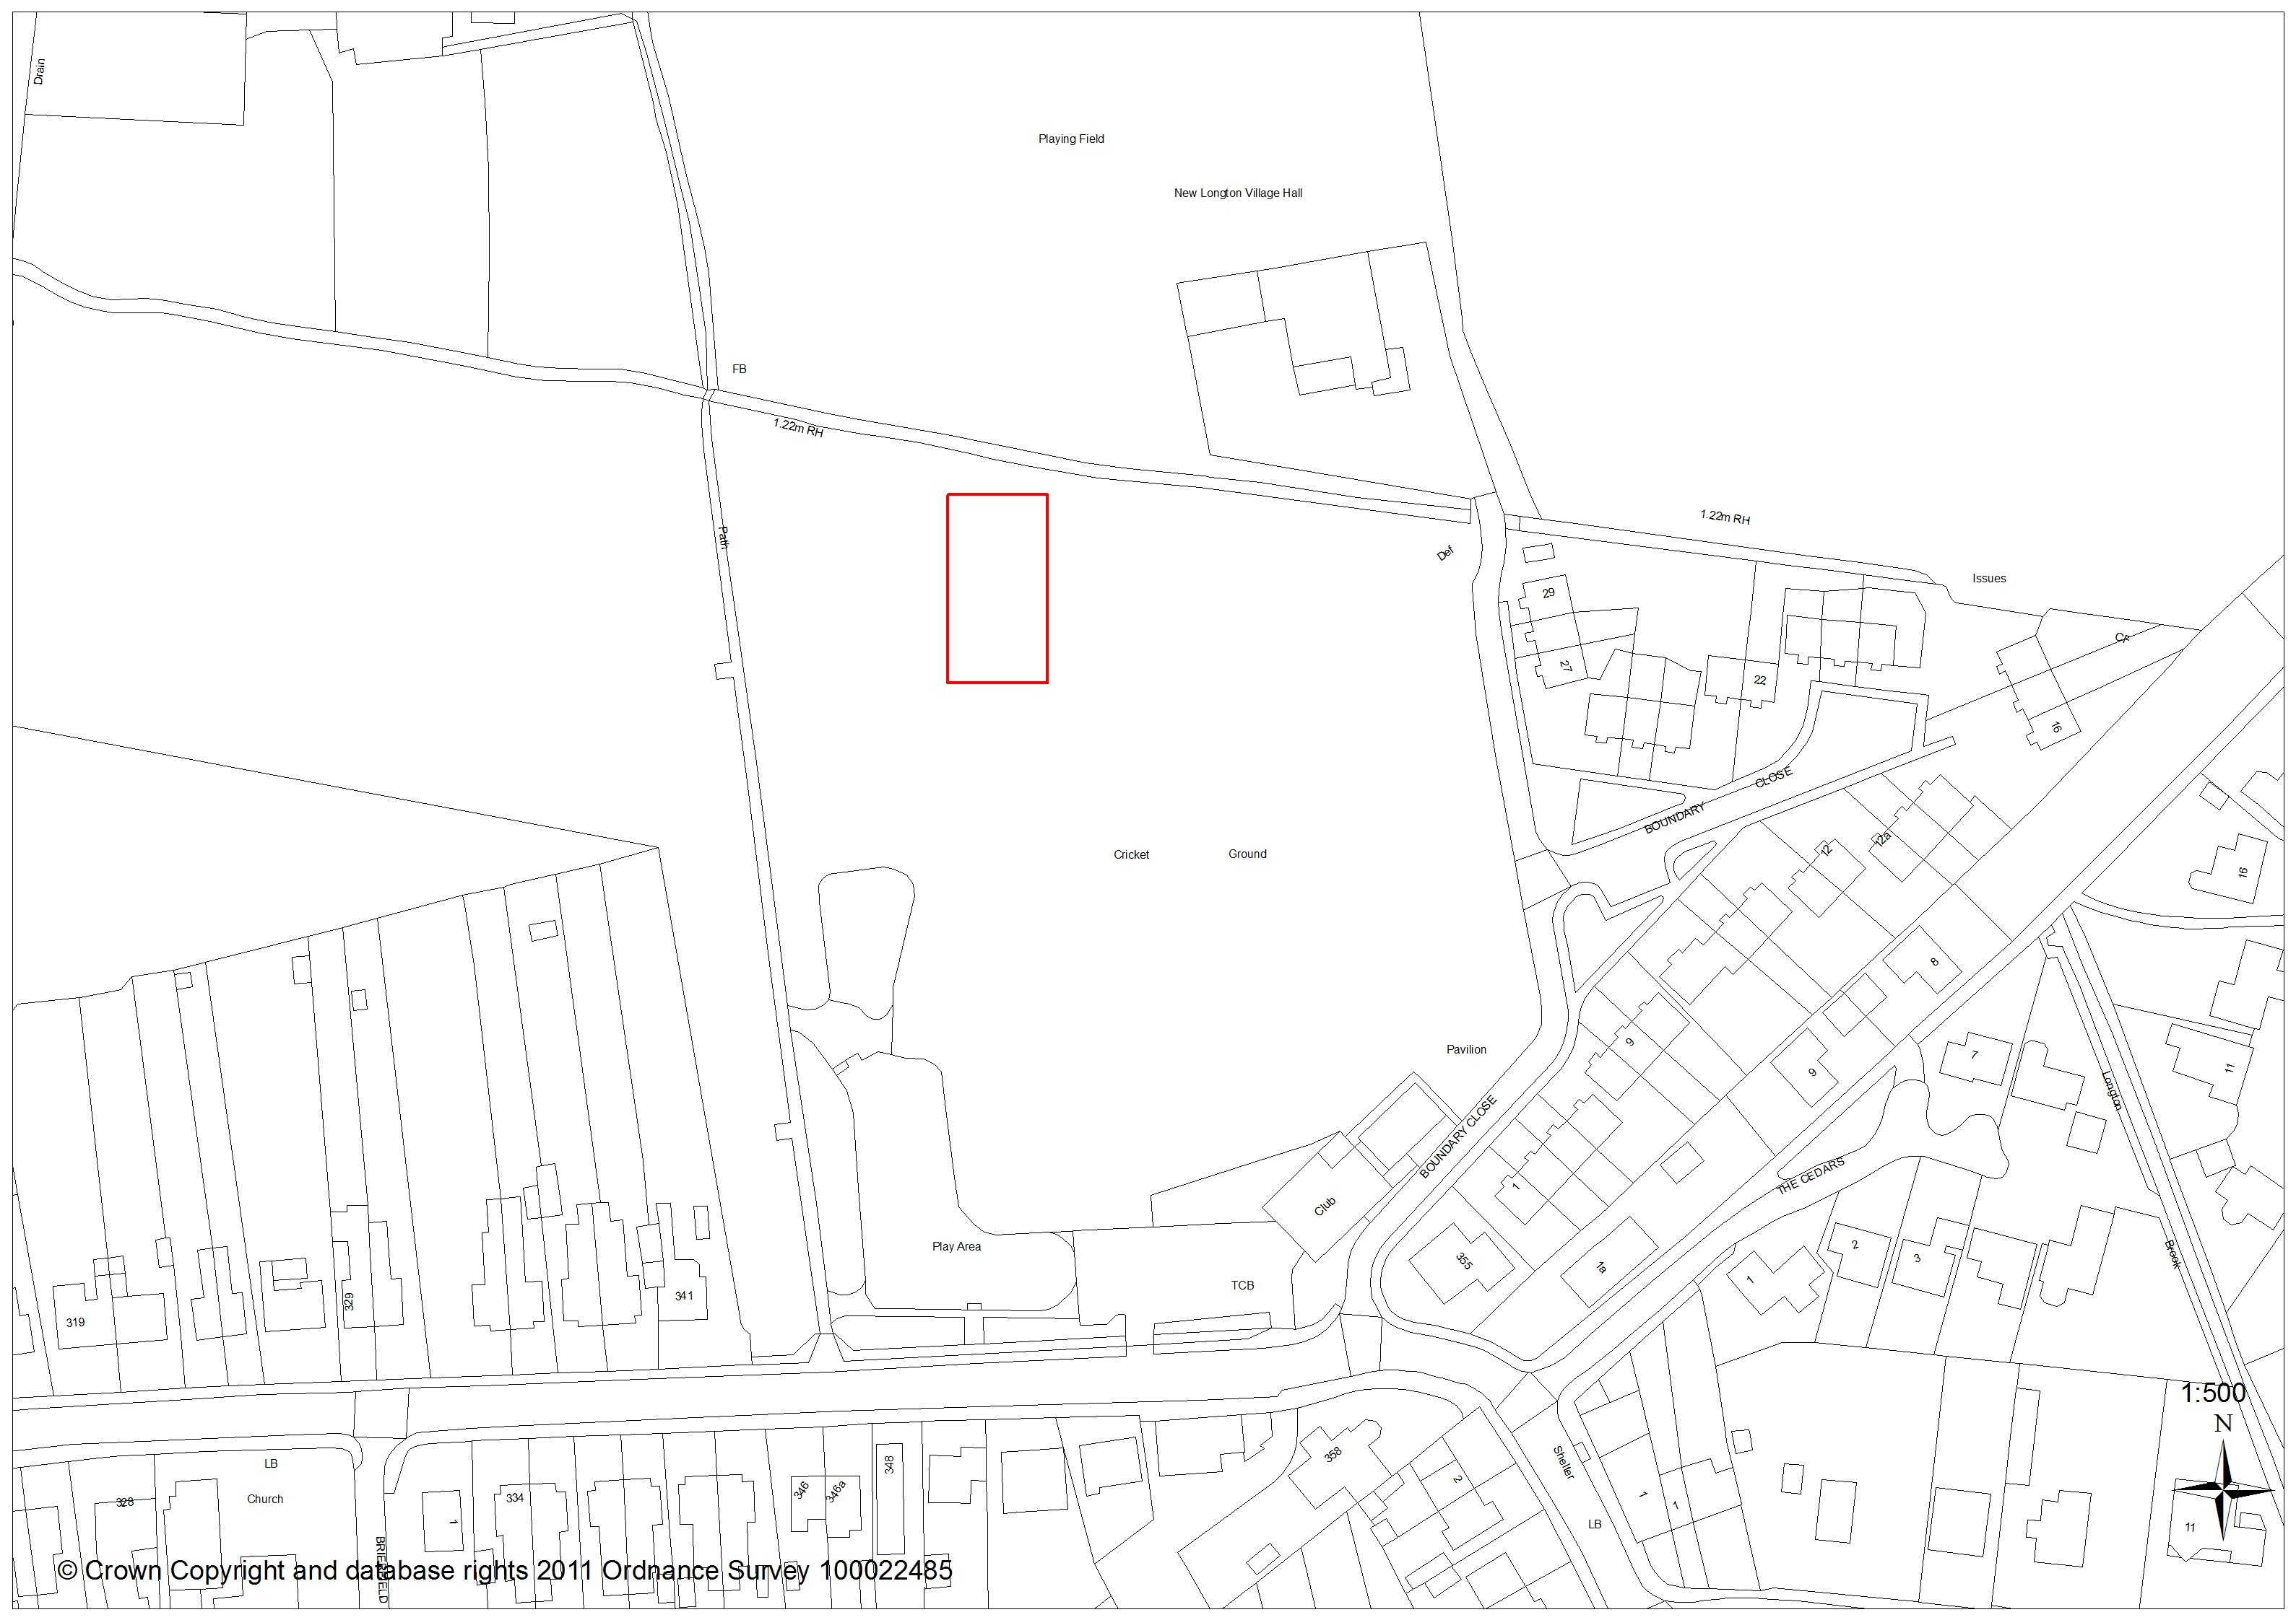

- Introduction

  - The application is brought before Committee as a number of Council Officers are Cricket Club members.

- Summary

  - The application proposes erection of a fully enclosed, two bay, cricket practice net on land to the northern edge of New Longton Cricket Ground.

  - The units design and placement are such that any loss of visual amenity would be limited, and any loss of useable sports field would be avoided.

  - In line with adopted local and national policy the proposal supports the retention and upgrade of existing sports facilities, and having regard to the material considerations detailed below it is recommended that permission is granted subject to the imposition of conditions.

- Application Site and Surrounding Area

  - The application refers to New Longton Cricket Club; a large tract of Council owned land designated as Green Infrastructure by Policy G7 of the South Ribble Local Plan.

  - The ‘L’ shaped site accommodates a children’s play area, cricket club, parking areas and pavilion along the southern edge, but in the main is open in nature and used as playing field. A number of larger, single trees are present around the site edges but none are protected by Tree Preservation Order.

  - The northern boundary is denoted by both Longton Brook and mature trees; beyond which are New Longton Village Hall and playing fields. In the east, south and west are Boundary Close and Chapel Lane (residential and mixed use respectively), and dissecting the site in a north-south direction is public right of way PROW 7-7-FP47.

  - There are no recorded issues of flooding on the site

- Site Context / Planning History

  - There are eleven planning applications on the history of this site. These all pre-date 2006, relate to redevelopment of the club house and car park, and are not relevant to the proposal to be determined.

- Proposal

  - The applicant seeks permission for erection of an enclosed, two-lane, cricket practice net structure on land to the northern side of the site.

  - The unit would be 33m long x 7.3m wide, with a maximum height of 4m. Its steel frame would support mesh netting protection, and access would be via pedestrian door set into the eastern elevation. The floor would be a combination of green/blue synthetic playing surface and sand dressed carpet

- Summary of Supporting Documents

  - The application and proposal drawings are accompanied by the following:
  - Phase 1 Habitat Survey (Wildlife Trust: 12.10.18)
  - Project Specifications (Total Play: 7.11.18)
  - Himalayan Balsam Management Statement (John Lamb)

- Representations

  - Summary of Publicity

    - A site notice has been posted and twenty six neighbouring properties have been consulted.

  - Letters of Objection or Support

  - One letter of support has been received from the occupant of no: 2 Boundary Close (130m south-east).

  - A letter objecting to the proposal has also been received from the resident of 341 Chapel Lane whose garden abuts the western site boundary at approximately 110m away. This residents comments are summarised as:

- Lack of adequate parking as the club has increased in size
- Existing issues of parking on Chapel Lane when functions are held in the club house
- Request that ‘double yellow lines’ are installed

- Summary of Responses

  - South Ribble Legal Department confirms that there is no requirement to obtain landlords consent under the terms of the clubs lease

  - Sport England confirm that the proposed development would support the sites principal, playing field use and will not affect the quantity and quality of the pitches or their use. Discussions with the English Cricket Board confirm that the proposals design is acceptable and as such Sport England does not object.

  - Lancashire County Council Highways have no objection

  - The Councils Ecologist confirms that the development footprint has little ecological value, but has concerns that development may impact upon Longton Brook during construction works. Conditions to protect the brook, to ensure compliance with the applicants Himalayan Balsam Management Statement and to require installation of 2 no: bird boxes are therefore recommended.

- Material Considerations

  - Site Allocation/Relevant Policy Background

    - The cricket club sits within an area designated under Policy G7 of the Local Plan 2012-2026 as Existing Green Infrastructure. G7 states that development proposals should seek to protect and enhance the existing green infrastructure. Proposals will not be permitted on lands designated by this policy unless alternative provision of similar and/or better facilities for the community will be implemented on another site or within the locality, or it can be demonstrated that retention of the site is not required to satisfy a recreational need in the local area, and where the development would not detrimentally affect the amenity or nature conservation value of the site.

    - Additional policy of marked relevance to this proposal is as follows:

- National Planning Policy Framework (2018)

    - The NPPF at Para 11: provides a presumption in favour of sustainable development, supporting amongst other things ‘strong vibrant and healthy communities’ and by ‘fostering open spaces that reflect current and future needs with accessible open spaces which support community health, social and cultural wellbeing’

    - Chapter 6: Building a strong, competitive economy at Para 83 states that planning policies and decisions should enable … ‘leisure developments which respect the character of the countryside’ and ‘the retention and development of accessible local services – including sports venues’

    - Chapter 8: Promoting Healthy & Safe Communities says that planning policy and decisions should ‘plan positively for the provision of shared spaces (such as sports venues) … to enhance the sustainability of communities’. Planning should also ‘take into account and support local strategies to improve health, social and cultural wellbeing for all sections of the community’

    - Chapter 15: Conserving and Enhancing the Natural Environment – when determining planning applications, Local Planning Authorities should aim to conserve and enhance biodiversity as reflected by Core Strategy Policy 22.

- Central Lancashire Core Strategy

    - The Core Strategy was adopted at full Council on 18th July 2012, and is therefore a material consideration in the determination of this planning application.

    - Policy MP states that the Council will take a positive approach reflecting the NPPF presumption in favour of sustainable development, and in accordance with the Local Plan unless material considerations indicate otherwise.

    - Policy 17: Design of New Buildings requires new development to take account of the character and appearance of the local area.

    - Policy 22: Biodiversity & Geodiversity aims to conserve, protect and seek opportunities to enhance and manage the biological and geological assets of the area

    - Policy 24: Sport & Recreation aims to protect existing sport and recreation facilities, and identify new facilities where there is evidence of need.

- South Ribble Local Plan

    - In addition to site allocation policy G7 (above), the following are also pertinent:

    - Policy G16 –Biodiversity and Nature Conservation protects, conserves and enhances the natural environment at a level commensurate with the site’s importance and the contribution it makes to wider ecological networks.

    - Policy G17: Design Criteria for New Development considers design in general terms, and impact of the development upon highways safety, the extended locale and the natural environment.

    - Central Lancashire Open Space and Playing Pitch SPD sets out the standards for provision of on and off site open space and playing pitch provision, but also provides a strategic framework for improvement of existing ancillary facilities such as cricket and artificial grass pitches.

  - Impact of Development on Neighbouring Properties

  - The closest residential properties would be those on Boundary Close in the east at between 90m and 130m away, and on Chapel Lane in the south at 140m distance. No: 341 Chapel Lane is the closest in the south-west at 60m from the rear garden boundary and 120m from the property itself. Noise from the proposal would be similar to that which already exists, and spatial separation between neighbouring properties and the completely enclosed practice unit is also considered more than acceptable.

  - Design, Appearance and Character

  - In design terms the proposal – which would be relatively transparent – is considered appropriate for its surroundings, and should not look out of place in a sports setting.

  - Highways, Access and Parking Arrangements

  - Although objection has been made with regards to parking on the site, the nets are expected to be used by existing club members. As such traffic generation should not increase significantly, and access and parking arrangements will remain the same

  - Natural Environment

  - Subject to appropriate protection during construction, the proposal should not impact in any way upon the natural environment.

- Conclusion

  - The unit in question clearly supports sports provision in line with adopted policy, and has been located both to be visually unobtrusive, and to avoid any detrimental loss of active sports playing areas. There is no environmental impact as the unit sits alongside rather than in the place of trees and shrubbery, and enables the long term, purposeful use of the playing fields.

  - The proposal is considered to accord well to the sentiments of the policies detailed above, and is recommended for approval subject to the imposition of conditions.

RECOMMENDATION:

Approval with Conditions.

RECOMMENDED CONDITIONS:

1. The development hereby permitted must be begun not later than the expiration of three years beginning with the date of this permission.
REASON: Required to be imposed pursuant to Section 91 of the Town and Country Planning Act 1990.

2. The development, hereby permitted, shall be carried out in accordance with the submitted approved plans
Dwg EN03 & EN04 (Total Play: 19.11.18)
Phase 1 Habitat Survey (Wildlife Trust: 12.10.18)
Project Specifications (Total Play: 7.11.18)
Himalayan Balsam Management Statement (John Lamb)
REASON: For the avoidance of doubt and to ensure a satisfactory standard of development

3. Before any site activity (construction or demolition) is commenced in association with the development, barrier fencing shall be erected around all trees within proximity of the development area, and areas of Longton Brook which might be affected by construction. The fencing shall be constructed and located in compliance with BS 5837 2012 - Trees in Relation to Design, Demolition and Construction - Recommendations. Within these fenced areas no development, vehicle manoeuvring, storage of materials or plant, removal or addition of soil may take place. This includes ground disturbance for utilities. The fencing shall not be moved in part or wholly without the written agreement of the Local Planning Authority. The fencing shall remain in place until completion of all development works and removal of site vehicles, machinery, and materials in connection with the development.
REASON: To prevent damage to trees during construction works in accordance with Policy G13 in the South Ribble Local Plan 2012-2026

4. Development shall proceed in accordance with the recommendations of the approved Himalayan Balsam Management Statement (John Lamb)
REASON: The spread of invasive plants is prohibited under the Wildlife and Countryside Act 1981. Without measures to prevent spread as a result of the development there would be the risk of an offence being committed and avoidable harm to the environment recurs

5. Prior to first use of the nets hereby approved, two bird boxes shall be erected within or around the site in accordance with approved Phase 1 Habitat Survey (Wildlife Trust: 12.10.18). Once provided these shall be retained and maintained thereafter unless otherwise agreed with the local planning authority.
REASON: To ensure adequate provision is made for these protected species in accordance with Policy 22 of the Central Lancashire Core Strategy and Policy G16 in the South Ribble Local Plan 2012-2026

RELEVANT POLICY

NPPF National Planning Policy Framework

Central Lancashire Core Strategy
17 Design of New Buildings
22 Biodiversity and Geodiversity
24 Sport and Recreation

Local Plan 2012-2026
G16 Biodiversity and Nature Conservation
G17 Design Criteria for New Development

Open Space and Playing Pitch Supplementary Planning Document

